Ex.no:2 | EDA-DATA IMPORT AND EXPORT

Aim:
To inspect the features of the California Housing Dataset, detect missing and duplicate values, analyze housing attributes and categorical distributions, and export the data into CSV, Excel, JSON, and SQLite database formats.
Algorithm:
- Import Pandas, OS, and SQLite3 libraries.
- Read the housing prices CSV file using pd.read_csv().
- Inspect the dataset structure using .head(), .tail(), .info(), .describe(), and .isnull().sum().
- Display the shape, columns, data types, and duplicate records of the dataset.
- Analyze the distribution of ocean proximity categories.
- Analyze housing features such as median house value, median income, total rooms, and population.
- Calculate the correlation between numerical attributes.
- Identify the top 10 records based on median house value.
- Export the DataFrame into CSV, Excel, and JSON formats.
- Connect to a SQLite database and store the dataset in an SQL table using .to_sql().
11.Close the database connection and end execution.

Program:
import os
import pandas as pd
import sqlite3

# Load dataset
path = "/content/"
print("Dataset path:", path)

df = pd.read_csv(os.path.join(path, "housing prices.csv"))

print("\nFirst 5 rows:")
display(df.head())

print("\nLast 5 rows:")
display(df.tail())

print("\nDataset information:")
df.info()

print("\nShape:")
print(df.shape)

print("\nColumns:")
print(df.columns.tolist())

print("\nData types:")
print(df.dtypes)

print("\nStatistical description:")
display(df.describe(include="all").T)

print("\nMissing values:")
display(df.isnull().sum())

print("\nDuplicate rows:")
print(df.duplicated().sum())

print("\nOcean proximity:")
display(df["ocean_proximity"].value_counts())

print("\nTop records by median house value:")
display(
df.sort_values("median_house_value", ascending=False)
.head(10)[
["longitude", "latitude", "median_income",
"total_rooms", "median_house_value", "ocean_proximity"]
]
)

print("\nCorrelation:")
display(df.corr(numeric_only=True))

# Export files
df.to_csv("housing_prices_data.csv", index=False)
df.to_excel("housing_prices_data.xlsx", index=False)
df.to_json("housing_prices_data.json", orient="records", indent=4)

# SQLite database
conn = sqlite3.connect("housing_prices.db")
df.to_sql("housing_data", conn, if_exists="replace", index=False)
conn.close()

print("\nCSV, Excel, JSON and SQLite files created successfully.")

Output:
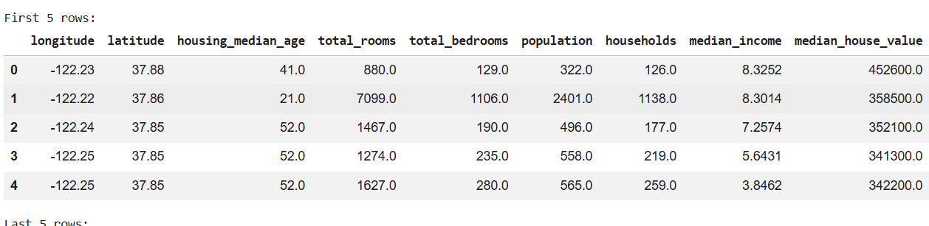

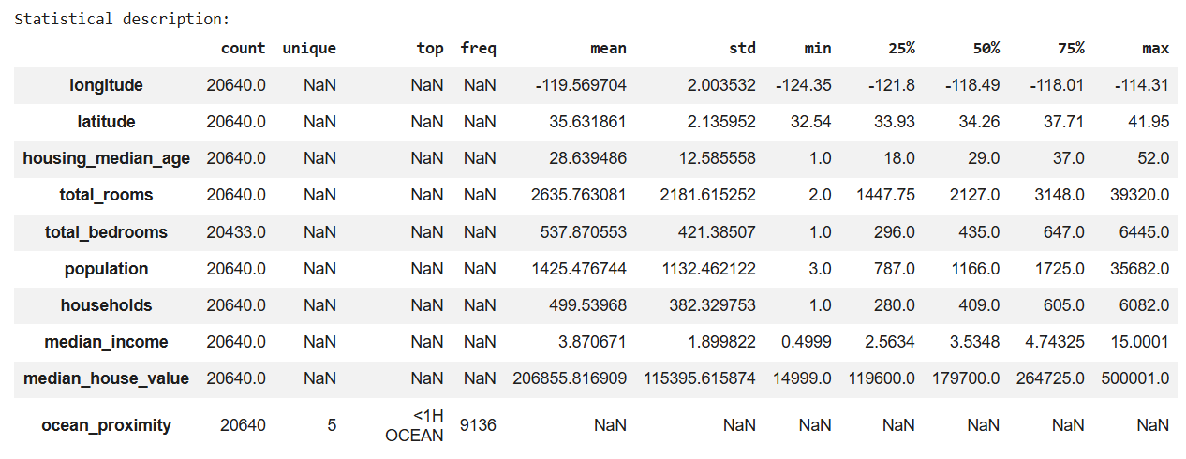

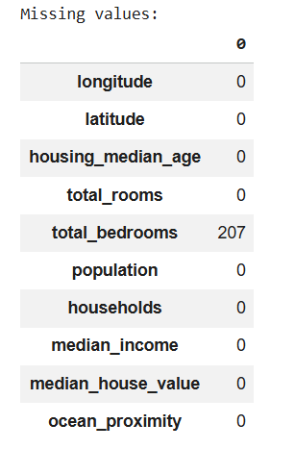

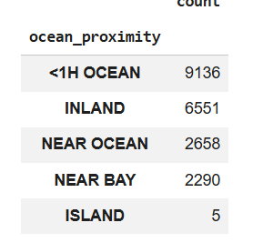

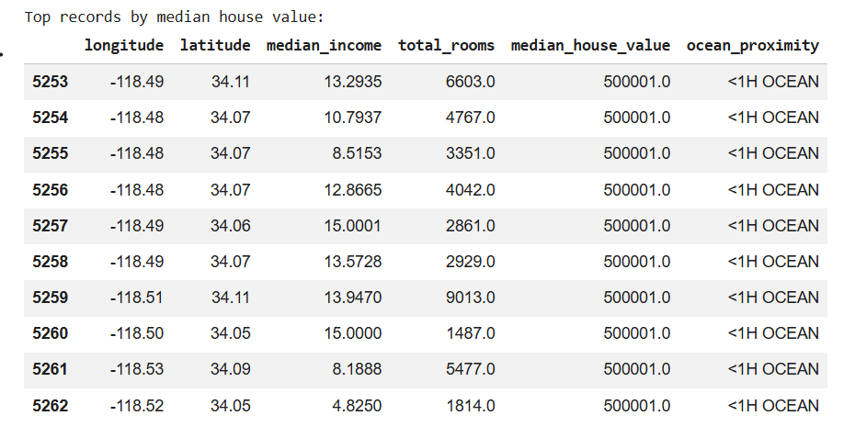

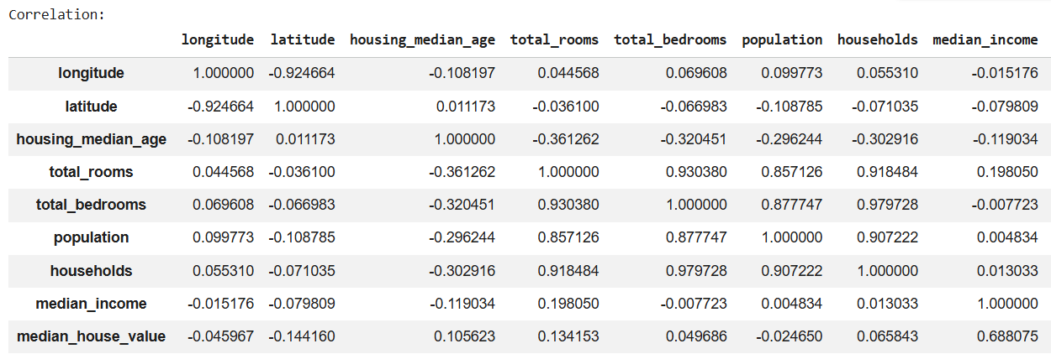

Result:

